<https://www.youtube.com/watch?v=6if4pntcVPA>

NOTA: NO ES ASP.NET Core Web App, es ASP.NET Core Web Api

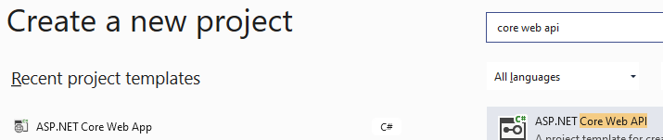

Install-Package Microsoft.EntityFrameworkCore -Version 3.1.14

To avoid the error for UseSqlServer

Install-Package Microsoft.EntityFrameworkCore.SqlServer -Version 3.1.15

Could not load file or assembly 'Microsoft.Bcl.AsyncInterfaces

Install-Package Microsoft.Bcl.AsyncInterfaces

Install-Package Pomelo.EntityFrameworkCore.MySql

Create folder **Models**

Add Class LOBs

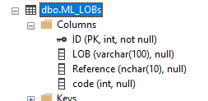

namespace ProductsApp.Models

{

public class LOBs

{

public int ID { get; set; }

public string LOB { get; set; }

public string Reference { get; set; }

public int code { get; set; }

}

}

**Create folder Context**

Add Class AppDbContext, y agregue : DbContext

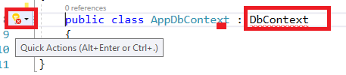

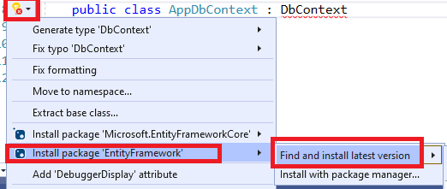

using Microsoft.EntityFrameworkCore;

using WebApplication11.Models;

namespace WebApplication11.Context

{

public class AppDbContext : DbContext

{

public AppDbContext(DbContextOptions<AppDbContext> options) : base(options)

{

}

public DbSet<LOBs> LOB_All { get; set; }

}

}

**Archivo Appsettings.json**

"AllowedHosts": "*",

"ConnectionStrings": {

"Conexion": "data source=(localdb)\\MeLi;initial catalog=MeLi;Persist security info=True;Integrated Security=SSPI;"

}

}

**ARCHIVO Startup.cs**

using Microsoft.EntityFrameworkCore;

using WebApplication11.Context;

public void ConfigureServices(IServiceCollection services)

{

services.AddControllers();

services.AddDbContext<AppDbContext>(options => options.UseSqlServer(Configuration.GetConnectionString("Conexion")));

}

**Agregar controlador**

Controller / Add / New Item

LOBController

using WebApplication**11**.Context;

namespace WebApplication11.Controllers

{

[Route("api/[controller]")]

[ApiController]

public class LOBController : ControllerBase

{

private readonly AppDbContext context;

//Constructor, del mismo nombre que la clase

public LOBController(AppDbContext context)

{

this.context = context;

}

// Traiga todo

// Get: api/<controller>

[HttpGet]

public ActionResult Get()

{

try

{

// Refer to AppDbContext File, LOB_All

return Ok(context.LOB_All.ToList());

}

catch (Exception ex)

{

return BadRequest(ex.Message);

}

}

// Traiga uno por id

// Get: api/<controller>/5

[HttpGet("(id)", Name = "GetLOB")]

public ActionResult Get(int id)

{

try

{

var LOB = context.LOB_All.FirstOrDefault(f => f.ID == id);

return Ok(LOB);

}

catch (Exception ex)

{

return BadRequest(ex.Message);

}

}

}

}

https://localhost:44301/api/LOB

// POST: HomeController/Create

[HttpPost]

[ValidateAntiForgeryToken]

public ActionResult Create(IFormCollection collection)

{

try

{

return RedirectToAction(nameof(Index));

}

catch

{

return View();

}

}

**Troubleshoot**

Check project / Edit Project File

<Project Sdk="Microsoft.NET.Sdk.Web">

<PropertyGroup>

<TargetFramework>netcoreapp3.1</TargetFramework>

</PropertyGroup>

<ItemGroup>

<PackageReference Include="Microsoft.AspNetCore.Identity.EntityFrameworkCore" Version="5.0.11" />

<PackageReference Include="Microsoft.AspNetCore.Identity.UI" Version="5.0.11" />

<PackageReference Include="Microsoft.Bcl.AsyncInterfaces" Version="5.0.0" />

<PackageReference Include="Microsoft.EntityFrameworkCore" Version="5.0.11" />

<PackageReference Include="Microsoft.EntityFrameworkCore.SqlServer" Version="3.1.7" />

</ItemGroup>

</Project>

<PackageReference Include="Microsoft.AspNetCore.Identity.EntityFrameworkCore" Version="3.1.4" />

<PackageReference Include="Microsoft.AspNetCore.Identity.UI" Version="3.1.10" />

<PackageReference Include="Microsoft.EntityFrameworkCore.SqlServer" Version="3.1.15" />

<PackageReference Include="Microsoft.Bcl.AsyncInterfaces" Version="5.0.0" />

<PackageReference Include="Microsoft.EntityFrameworkCore" Version="5.0.11" />

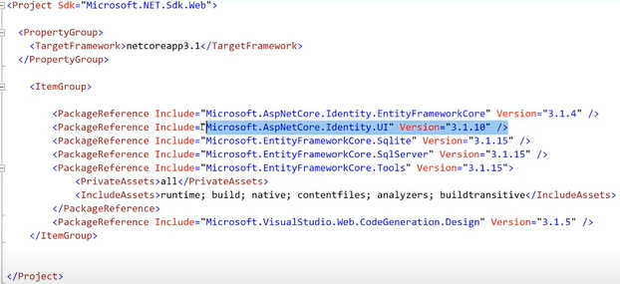

Could not load file or assembly 'Microsoft.Bcl.AsyncInterfaces

Install-Package Microsoft.Bcl.AsyncInterfaces

**System.InvalidOperationException:** 'The database provider attempted to register an implementation of the 'IRelationalTypeMappingSource' service.

This is not a service defined by Entity Framework and as such must be registered as a provider-specific service using the 'TryAddProviderSpecificServices' method.'

Install-Package Pomelo.EntityFrameworkCore.MySql

**System.TypeLoadException:** 'Method 'Create' in type 'Microsoft.EntityFrameworkCore.SqlServer.Query.Internal.SqlServerSqlTranslatingExpressionVisitorFactory' from assembly 'Microsoft.EntityFrameworkCore.SqlServer, Version=3.1.15.0, Culture=neutral, PublicKeyToken=adb9793829ddae60' does not have an implementation.'

|  |  |
| --- | --- |
| Database | Package |
| SQLite | Microsoft.EntityFrameworkCore.Sqlite |
| Microsoft SQL Server | Microsoft.EntityFrameworkCore.SqlServer |

**LAUNCH CONTROLLER**

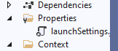

},

"profiles": {

"IIS Express": {

"commandName": "IISExpress",

"launchBrowser": true,

"launchUrl": "weatherforecast",

"environmentVariables": {

"ASPNETCORE_ENVIRONMENT": "Development"

}

},